 |  | R V College of Engineering  Department of Computer Science and Engineering  Improvement CIE: Scheme
Subject :  (Code) |  | COMPILER DESIGN (CS363AI) |  |  | Semester : 6th BE
Date : JUNE 2025 |  |  | Duration : 120 minutes | Staff : DD/SB/SNM/SMS/PK
Name : |  |  | USN : | Section : A,B,C,D,ISE
Si.No | Part A  Quiz Questions |  |  |  |  |  | M | BT | Co
1.1 | Short circuit codes are the Boolean operators &&, || and ! translations into jumps.---1 mark  Example --- 1 mark |  |  |  |  |  | 2
1.2 | Consider the grammar below:  S->SS+ | SS* | a  If I ={S->S.S+} compute Closure of (I).  Closure(I)={ S->S.S+, S->.SS+, S->.SS*, S->.a} |  |  |  |  |  | 2
1.3. | If x<100 goto L2  goto L3  L3: if x>200 goto L4  goto L1  L4: if x!=y goto L2  goto L1  L2: x=2  L1: |  |  |  |  |  | 2
1.3 | Construct a DAG for the following basic block:  T1=A+B  T2=C+D  T3=E-T2  T4=T1-T3 |  |  |  |  |  | 2
1.4 | Backpatch(p,i) |  |  |  |  |  | 1
1.5 | Write the backpatching SDT for the following production:  B→B1 && M B2  {B.truelist= B2.truelist;  B.falselist = merge(B1.falselist,B2.falselist);  Backpatch(B1. Truelist, M.instr);} |  |  |  |  |  | 1
1.6 | It loads into register R1 the value given by contents(contents(100+contents(R2))) and the cost is 3.
 | Part B
2 | Write the different techniques for optimizing basic blocks with examples.  - The DAG representation of Basic Blocks  - Finding local common subexpression  - Dead code elimination  - The use of Algebraic Identities  - Representation of array references  - Pointer assignments and procedure calls  Any 5 points with example = 2* 5 = 10 marks |  |  |  |  |  | 10 | L4 | CO4
3 | Consider the following source code:  for i from1 to 10 do  for j from 1 to 10 do  C [ i, j]= A[i,j]+B[i,j];  - Write the TAC considering the array sizes as 10 X 12 where each element takes 4 bytes of memory space.  - Identify the leaders and form the basic blocks  - Draw the flow graphs and identify the loops if one exists  Ans:a) Three address code with properly manipulating the array addresse and jump statements. ---- 4 Marks  b) Identifying more atleast 6 leaders properly – 3 Marks  c) Neatly drawing the flow graphs –3 Marks |  |  |  |  |  | 4+3+3 | L3 | CO3
4. | Explain the main issues in code generation with examples for each of the issues in detail.  - Input to the code generation  - The Target program  - Instruction Selection  - Register allocation  - Evaluation order  Explanation + Examples ----- 2 X5 =10 Marks |  |  |  |  |  | 10 | L2 | CO4
5. | How the following basic block can be optimized?  1. a=10  2. b=4*a  3. t1=i*j  4. c=t1+b  5. t2=15*a  6. d=t2*c  7. e=i  8. t3=e*j  9. t4=i*a  10. c=t3+t4  Optimized code:  1. a=10  2. b=4*a  3. t1=i*j  4. c=t1+b  5. t2=15*a  6. d=t2*c  7. t4=i*a  8. c=t3+t4  With proper reason --- 6 Marks  Explain with examples Peephole optimization. --- 4 Marks |  |  |  |  |  | 5+5 | L3, L2 | CO4
6. | Using backpatching manipulate the Truelist and the Falselist at the root node of the annotated parse tree, which should be constructed for the expression: a<b && b>c && a!=d.  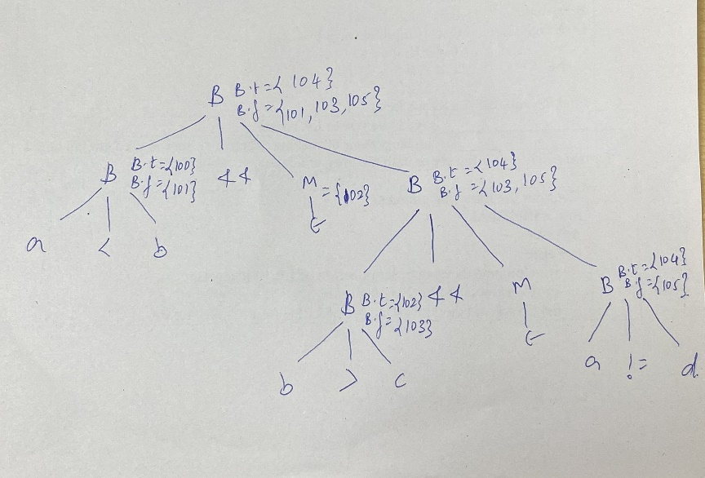 |  |  |  |  |  | 10 | L4 | CO4

